
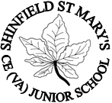

Top of Form
Bottom of Form

Shinfield St Mary’s Church of England Junior School

Admissions policy 2027-2028

Our Vision

Jesus said ‘As I have loved you, so you must love one another.’ John 13, 34

This commandment guides us all to love and value all members of the school community. Children and adults from all backgrounds will thrive in the belief that diversity is to be celebrated and respected. As well as loving those who are present in our lives they will interact in the world in ways that reflect their responsibilities as global citizens and custodians of our planet. Our children will make an impact in the wider world which will benefit future generations

Introduction
  - Shinfield St. Mary’s Church of England Junior School values highly its Christian ethos, its close links with the local church and the Diocese of Oxford. We provide a distinctively Christian, yet inclusive, environment in which each child is motivated to acquire skills for life and a love of learning. As a church school we welcome applications from Christian families and those of other faiths or none. We ask all parents applying for a place at our school to respect this ethos and its importance to the whole school community.
  - The Governing Body is responsible for deciding admissions to the school. The Local Authority (LA) (Wokingham Borough Council), through the coordinated admission arrangements, manages the application process. The school MUST inform the LA by 1st October each year whether or not we wish to continue with these arrangements.
  - A pupil is enrolled at this Aided School in accordance with the Governors' Admissions Policy. This has been published after consultation with the Oxford Diocesan Board of Education, the Local Authority and other relevant admission authorities, in accordance with the School Admissions Code. All applications will be treated fairly, in order of the admissions criteria, irrespective of the need or ability of the child.
  - The only restriction we place on entry is that of Pupil Admission Number (PAN). Our PAN at entry level (Y3) is 90. If the number of children applying for entry exceeds the places available, we enforce the procedure set out below in order to determine whether a child is accepted or not. It is our wish to allow parents the right to have a place at their preferred school. This, however, is not always possible when demand exceeds the number of places available.

Aims and objectives
  - We are an inclusive school that welcomes children from all backgrounds and abilities.
  - All applications will be treated equally and in a sensitive manner.

Admission Arrangements to Year 3 in September 2027
  - Parents (see Note 1) wishing to apply for a Year 3 place in September 2027 must complete the common application form provided by their home local authority (the home LA), which is available via an online process. The home LA is the LA in whose area the parents live at the time of the application. All parents of children in Year Two will receive a personalised computer-generated letter containing their child’s UID (Unique Identifier), for use in the admissions process.
  - There are 90 places available (the published admission number or PAN) in Year 3 in September 2027.
  - Online admissions open for online applications for entry to Year 3 at Shinfield St. Mary's Church of England Junior School on November 13th 2026, (see below, 3.4) and should be received by the local authority by January 15, 2027. Offers of a place will be sent out by the LA by April 16th, 2027. Parents must accept offers before 4th May, 2027.
Applications received after the deadline for receipt will only be considered after all those received by the deadline. This means that, if no places are left after considering all the applications received by the deadline, the application will be unsuccessful.
  - The online admissions service will open for applications on November 13th 2026. Help and advice can be obtained by telephoning (0118) 974 6000 or by emailing schooladmissions@wokingham.gov.uk. This service offers a fast, simple and easy process, ensuring that the application form is completed correctly if the UID (see 3.1) is used, if applying under criterion 3 (home address) in the designated area. There is a map in this policy showing the designated area. Living in the designated area is not a guarantee of an offer of a place at the school (See Appendix 3 for map).
  - At Shinfield St. Mary's Church of England Junior School, pupils are normally admitted at the beginning of the academic year (1 September) in which they reach their eighth birthday, without reference to ability or aptitude. Entry in September 2027 is therefore open to all children born between September 1, 2020 and August 31, 2021.
  - The Admissions Forum for Wokingham Local Authority Schools has agreed arrangements to secure the timely placement of all pupils in schools. These protocols have been adopted into the admission arrangements agreed by the governors for Shinfield St. Mary's Church of England Junior School. The school will be participating with the LA In-Year Fair Access Protocols. All applications should be made in accordance with the LA's coordinated admissions policy.

Admission Criteria
Children with an Education, Health and Care (EHC) plan naming Shinfield St Mary’s Church of England Junior School will always be offered places if it would be of benefit to them (we can meet their needs). If there is then greater demand for admission than there are places available, the following criteria will be applied in the order set out below:
- Looked-after children and children who were previously looked after, including those children who appear to have been in state care outside England, but ceased to be so as a result of being adopted.
- Children on the roll of Shinfield Infant & Nursery School on the date of application (See Note 5).
- Children who have a sibling on the roll of the school or on the roll of Shinfield Infant & Nursery School at the time of application and who is expected to be in attendance at the school at the time of their entry. (See Note 4).
- Children where their normal home address is in the designated area. (See Note 6).
- Other children.
The school’s Admissions Panel will rank applications for admission strictly according to the school admissions criteria and return this list to the LA by March 15, 2027.

Oversubscription Criteria
  - The Admission Criteria are only applied if there are more applications than places.
  - In the event of there being more applications than places available under any admissions criteria then priority will be given to the applicant whose normal home address (see Note 6) is nearest to Shinfield St. Mary’s Church of England Junior School. Distances will be measured using the LA’s method (details of which are found in the LA Parent’s Guide to Primary School Admissions).
  - In the case of twins or multiple births, or children born in the same academic year, and from the same family where the admission criteria would result in splitting children, places will be offered, even if this results in the school exceeding the admission number.

In-Year Admissions
Admissions for year groups other than the main entry year or for the main entry year after the offer of places in that year are co-ordinated by Wokingham Borough Council.

  - Applications should be on the in-year Common Application Form of the LA in which you live if that authority is operating a co-ordinated scheme and be sent to that LA for processing, or you may apply direct to Wokingham Borough Council. Wokingham BC will contact the school to ascertain whether or not there are places available and will make any offer on behalf of the school.
  - The Governing Body will only consider in-year admissions up to half a term in advance of the desired date for entry. For example, for entry in January the application will not be considered until after the October half term break. The over-subscription criteria above will be applied in the event of there being more applications than places available in the year group in question. Admission can be refused where the admission of another child would prejudice the provision of efficient education or efficient use of resources.
  - The Governors of the school will participate in the LA In-year Fair Access Protocol. This may result in the school being obliged to admit over its admission number. At Shinfield St Mary’s Church of England Junior School, participation in the Fair Access Protocol (FAP) may be delegated to the Headteacher. Guidance regarding FAP will be sought form the LA who will need to review the FAP for schools within their jurisdiction.

Admissions in September 2025
The school received 90 applications expressing a preference for admission to Year 3 by the closing date. 90 applications were successful.

Waiting Lists
  - Wokingham Borough Council manage our waiting lists. Any places that become available will be allocated according to the criteria in paragraph 4. Late applications will be processed by May 4th, 2027.

Parents’ Right of Appeal
  - The Appeals Code states that parents have 20 school days from the date of notification that their application was unsuccessful to prepare and lodge their written appeal. Appeals against refusal for entry should be sent in writing, with reasons, to the Admissions Clerk at the school. An independent panel will hear the appeal. An appeal panel's decision is binding for all parties concerned. If the panel decides that we should admit a child to our school, then we will accept this and continue to do all we can to provide the best education for all the children at our school. (Details of appeal arrangements are set out in the Schools Admissions Appeals Code).
  - Parents have a statutory right to appeal against the refusal of a place for which they have applied. This right does not apply if they are offered a place at the school but it is not in their preferred age group.
  - There were 0 appeals for admission to the school in the year 2025 – 26.
  - It should be noted that, in the event of an unsuccessful appeal against non-admission to the school, the school does not normally consider any further application in the same school year (1 September to 31 August). Parents have the right to a second application within the same academic year if there is a major change in circumstances e.g. change of address.

Additional Information
  - Additional information on the Admissions process can be obtained from the admissions clerk.
  - The school’s Equal Opportunity policy will operate in all cases of admissions to the school.
  - There is no charge or cost related to the admission of a child to the school.
  - Requests from parents for places outside a normal age group will be considered carefully e.g. for those who have missed education due to ill health, or Gifted and Talented pupils. Each case will be considered on its own merits and circumstances. However, such admissions will not normally be agreed without a consensus that to do so would be in the pupil’s interests. The governors will ask relevant professionals for their opinion on the case. Those refused places outside the normal age group will be informed of their statutory right to appeal.
  - This policy will be reviewed annually by the Governing Body.
  - In-year applications for all year groups will be administered by the LA in accordance with their published co-ordinated admissions scheme.

11 Contact Details
For further information, in the first instance, please contact the Admissions Clerk.  Admissions Clerk  Shinfield St. Mary's Church of England Junior School  Chestnut Crescent  Shinfield  Reading RG2 9EJ  Tel: (0118) 988 3663  admin@shinfield-st-marys.wokingham.sch.uk | To contact the LA:  Wokingham Borough Council  PO Box 156  Shute End,  Wokingham RG41 1WN  Tel: (0118) 974 6105  www.wokingham.gov.uk/admissions

Appendix 1 Notes

- Parent: a parent is any person who has parental responsibility for or is the legal guardian of the child.
- By a “looked-after child” we mean one in the care of a local authority or being provided with accommodation by a local authority in the exercise of its social services function. Previously looked after children are children who have been adopted, subject to child arrangement orders or special guardianship orders. Adopted children are those for whom an adoption order is made under the Adoption Act 1976 (Section 12) or the Adoption and Children Act 2002 (Section 46). A “child arrangements order” is one settling the arrangements to be made as to the person with whom the child is to live (Children Act 1989, Section 8, as amended by the Children and Families Act 2014, Section 14). A “special guardianship order” is one appointing one or more individuals to be a child’s special guardian/s (Children Act 1989, Section 14A). Applications under this criterion must be accompanied by evidence to show that the child is looked after or was previously looked after (e.g. a copy of the adoption, child arrangements or special guardianship order). Evidence that a child from outside England was previously in state care will be required to come within this criterion. A child is regarded as having been in state care outside England if they were in the care of or were accommodated by a public authority, a religious organisation, or any other provider of care whose sole or main purpose is to benefit society. Children/families with exceptional medical or social needs that make it essential that they attend Shinfield St. Mary’s Church of England Junior School rather than any other school. These needs must be fully supported by written evidence from the appropriate professional person involved with the family (See Note 3).
- Parents should request a letter from a registered health professional such as a doctor, Education Welfare Officer, social worker or other appropriate person setting out the particular reasons why this school is the most suitable school for the child and the difficulties that would be caused if the child had to attend another school. This supporting evidence will be brought before the full Governing Body and a decision made based on the ability of the school to best meet the needs of the child.
- Sibling; Sibling refers to brother or sister, half brother or sister, adopted brother or sister, step brother or sister, or the child of the parent/carer's partner where the child for whom the school place is sought is living in the same family unit at the same address as that sibling.
- Children attending or with an accepted place to attend Shinfield Infants School.
- By normal home address, we mean your child's home address. This is your child's permanent address at the time you make your application for a place. It is where you and your child live. We regard a child's home address to be where he or she spends the majority of the school week (Monday to Friday, including nights). We may ask to see some official documentation if there are reasons why a child does not live at his or her parents' address. For example, if he or she is resident with a grandparent, you need to tell us this on the application form. If you do not declare any arrangements like this, or use a relative's address for your application, we may consider that you have made a false declaration and withdraw the offer of a place. Childcare arrangements are not sufficient reasons for listing another address. The school reserves the right to check the validity of any address given, by asking for evidence such as inclusion on the Electoral Roll, or a recent utilities bill confirming your name and address.
If you are not sure whether or not you live in the designated area, you can ask the school to check this for you and you will receive a written response. If you are moving into the designated area, we will ask for evidence of your move before considering any application for a place. We need to know that you will be resident in the designated area on September 1, 2027. If you move later, we will still need evidence before considering an application. Typical evidence is a letter from your solicitor confirming that you have a legally binding agreement to buy the house or a formal lease agreement.
- Fair Treatment: All applications will be treated fairly, in strict order of the admission criteria, irrespective of need or ability of the child or family i.e. disabilities, special needs (without EHCPs) or challenging behaviour. The Shinfield St. Mary’s Church of England Junior School Admissions policy makes every effort to comply with all relevant legislation including that on class sizes and equal opportunities.

Applications to be received by: | Offers sent out by: | Parents to accept by: | Appeals lodged by:
15 January 2027 | 18 April 2027 | 3 May 2027 | 17 May 2027

Appendix 2 Summary of Dates

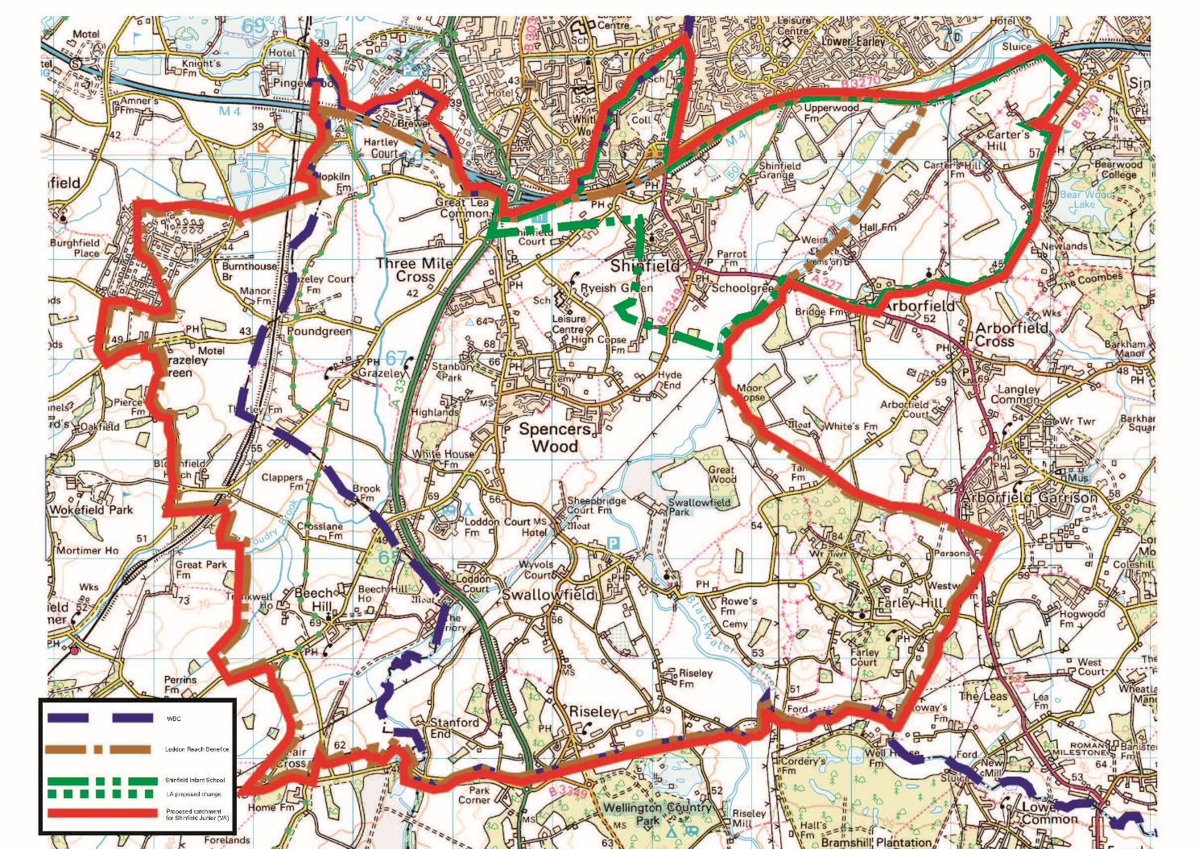
Appendix 3: Map of Designated Catchment Area

